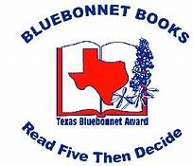2023 Texas Bluebonnet Award Results for Russell Elementary with 142 votes

3rd place with 14% of Votes was “Rock by Rock: The Fantastical Garden of Nek Chand” by Jennifer Bradbury illustrated by Boughton

2nd – Tied for second place with 16% of votes were –“ Bartali’s Bicycle: The True Story of Gino Bartali, Italy’s Secret Hero” written by Megan Hoyt, Illustrated by Lacopo Bruno &
Swish! The Slam-Dunking, Alley-Ooping, High-Flying Harlem Globetrotters by Suzanne Slade, Illustrated by Don Tate

1st place for Russell Students was “ Memoirs of a Tortoise”by Devin Scillan, Illustrated by Tim Bowers with 34% of Russell votes!

